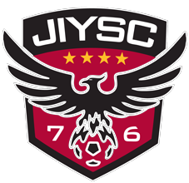
JIYSC
Refund Policy

Registration Fees for any circumstance other than injury or parent job relocation are Non-Refundable. Fees for participation with James Island Youth Soccer Club cover the entire soccer year (Initial Payment through July 31st of that seasonal year). A player who accepts an invitation to play with James Island Youth Soccer Club commits to pay the entire fee for the full soccer year. No refunds, partial or full, will be made to players who choose not to participate at any point after registration for any reason, including players suspended from the program

